Gradient Descent algorithm and its variants
Gradient Descent is an optimization algorithm used for minimizing the cost function in various machine learning algorithms. It is basically used for updating the parameters of the learning model.

Types of gradient Descent:
- Batch Gradient Descent: This is a type of gradient descent which processes all the training examples for each iteration of gradient descent. But if the number of training examples is large, then batch gradient descent is computationally very expensive. Hence if the number of training examples is large, then batch gradient descent is not preferred. Instead, we prefer to use stochastic gradient descent or mini-batch gradient descent.
- Stochastic Gradient Descent: This is a type of gradient descent which processes 1 training example per iteration. Hence, the parameters are being updated even after one iteration in which only a single example has been processed. Hence this is quite faster than batch gradient descent. But again, when the number of training examples is large, even then it processes only one example which can be additional overhead for the system as the number of iterations will be quite large.
- Mini Batch gradient descent: This is a type of gradient descent which works faster than both batch gradient descent and stochastic gradient descent. Here b examples where b<m are processed per iteration. So even if the number of training examples is large, it is processed in batches of b training examples in one go. Thus, it works for larger training examples and that too with lesser number of iterations.
Variables used:
Let m be the number of training examples.
Let n be the number of features.
Note: if b == m, then mini batch gradient descent will behave similarly to batch gradient descent.
Algorithm for batch gradient descent :
Let hθ(x) be the hypothesis for linear regression. Then, the cost function is given by:
Let Σ represents the sum of all training examples from i=1 to m.
Jtrain(θ) = (1/2m) Σ( hθ(x(i)) - y(i))2

Repeat {
θj = θj – (learning rate/m) * Σ( hθ(x(i)) - y(i))xj(i)
For every j =0 …n
}
Where xj(i) Represents the jth feature of the ith training example. So if m is very large(e.g. 5 million training samples), then it takes hours or even days to converge to the global minimum.That’s why for large datasets, it is not recommended to use batch gradient descent as it slows down the learning.
Algorithm for stochastic gradient descent:
1) Randomly shuffle the data set so that the parameters can be trained evenly for each type of data.
2) As mentioned above, it takes into consideration one example per iteration.
Hence,
Let (x(i),y(i)) be the training example
Cost(θ, (x(i),y(i))) = (1/2) Σ( hθ(x(i)) - y(i))2

Jtrain(θ) = (1/m) Σ Cost(θ, (x(i),y(i)))

Repeat {

For i=1 to m{

θj = θj – (learning rate) * Σ( hθ(x(i)) - y(i))xj(i)
For every j =0 …n

}
}
Algorithm for mini batch gradient descent:
Say b be the no of examples in one batch, where b < m.
Assume b = 10, m = 100;
Note: However we can adjust the batch size. It is generally kept as power of 2. The reason behind it is because some hardware such as GPUs achieve better run time with common batch sizes such as power of 2.
Repeat {
For i=1,11, 21,…..,91

Let Σ be the summation from i to i+9 represented by k.

θj = θj – (learning rate/size of (b) ) * Σ( hθ(x(k)) - y(k))xj(k)
For every j =0 …n

}

Convergence trends in different variants of Gradient Descents:
In case of Batch Gradient Descent, the algorithm follows a straight path towards the minimum. If the cost function is convex, then it converges to a global minimum and if the cost function is not convex, then it converges to a local minimum. Here the learning rate is typically held constant.
In case of stochastic gradient Descent and mini-batch gradient descent, the algorithm does not converge but keeps on fluctuating around the global minimum. Therefore in order to make it converge, we have to slowly change the learning rate. However the convergence of Stochastic gradient descent is much noisier as in one iteration, it processes only one training example.

ML | Stochastic Gradient Descent (SGD)
Gradient Descent in Brief

- Gradient Descent is a generic optimization algorithm capable of finding optimal solutions to a wide range of problems.
- The general idea is to tweak parameters iteratively in order to minimize the cost function.
- An important parameter of Gradient Descent (GD) is the size of the steps, determined by the learning rate hyperparameters. If the learning rate is too small, then the algorithm will have to go through many iterations to converge, which will take a long time, and if it is too high we may jump the optimal value.
Note: When using Gradient Descent, we should ensure that all features have a similar scale (e.g. using Scikit-Learn’s StandardScaler class), or else it will take much longer to converge.
Types of Gradient Descent:
Typically, there are three types of Gradient Descent:
- Batch Gradient Descent
- Stochastic Gradient Descent
- Mini-batch Gradient Descent
In this article, we will be discussing Stochastic Gradient Descent (SGD).

Stochastic Gradient Descent (SGD):
The word ‘stochastic‘ means a system or process linked with a random probability. Hence, in Stochastic Gradient Descent, a few samples are selected randomly instead of the whole data set for each iteration. In Gradient Descent, there is a term called “batch” which denotes the total number of samples from a dataset that is used for calculating the gradient for each iteration. In typical Gradient Descent optimization, like Batch Gradient Descent, the batch is taken to be the whole dataset. Although using the whole dataset is really useful for getting to the minima in a less noisy and less random manner, the problem arises when our dataset gets big.
Suppose, you have a million samples in your dataset, so if you use a typical Gradient Descent optimization technique, you will have to use all of the one million samples for completing one iteration while performing the Gradient Descent, and it has to be done for every iteration until the minima are reached. Hence, it becomes computationally very expensive to perform.
This problem is solved by Stochastic Gradient Descent. In SGD, it uses only a single sample, i.e., a batch size of one, to perform each iteration. The sample is randomly shuffled and selected for performing the iteration.
SGD algorithm:
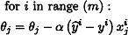
So, in SGD, we find out the gradient of the cost function of a single example at each iteration instead of the sum of the gradient of the cost function of all the examples.
In SGD, since only one sample from the dataset is chosen at random for each iteration, the path taken by the algorithm to reach the minima is usually noisier than your typical Gradient Descent algorithm. But that doesn’t matter all that much because the path taken by the algorithm does not matter, as long as we reach the minima and with a significantly shorter training time.
The path taken by Batch Gradient Descent –
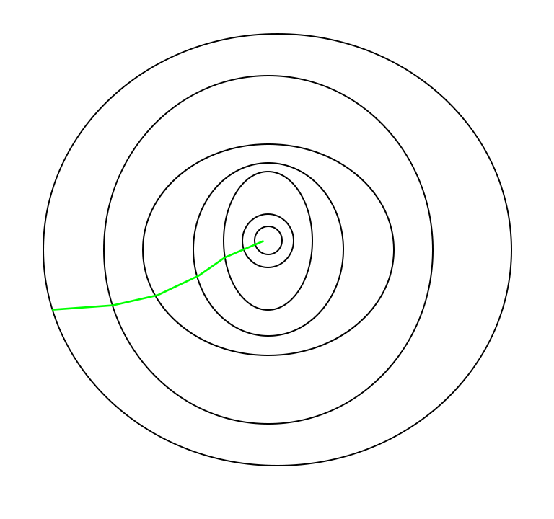
A path has been taken by Stochastic Gradient Descent –
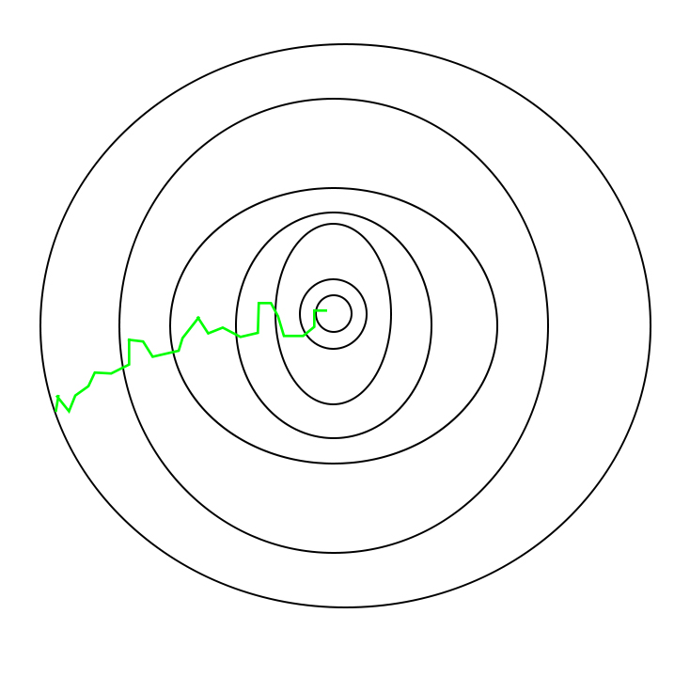
One thing to be noted is that, as SGD is generally noisier than typical Gradient Descent, it usually took a higher number of iterations to reach the minima, because of its randomness in its descent. Even though it requires a higher number of iterations to reach the minima than typical Gradient Descent, it is still computationally much less expensive than typical Gradient Descent. Hence, in most scenarios, SGD is preferred over Batch Gradient Descent for optimizing a learning algorithm.
Pseudocode for SGD in Python:

def SGD(f, theta0, alpha, num_iters):
"""
Arguments:
f -- the function to optimize, it takes a single argument
and yield two outputs, a cost and the gradient
with respect to the arguments
theta0 -- the initial point to start SGD from
num_iters -- total iterations to run SGD for
Return:
theta -- the parameter value after SGD finishes
"""
start_iter = 0
theta = theta0
for iter in xrange(start_iter + 1, num_iters + 1):
_, grad = f(theta)

# there is NO dot product ! return theta
theta = theta - (alpha * grad)

This cycle of taking the values and adjusting them based on different parameters in order to reduce the loss function is called back-propagation.

ML | Mini-Batch Gradient Descent with Python
In machine learning, gradient descent is an optimization technique used for computing the model parameters (coefficients and bias) for algorithms like linear regression, logistic regression, neural networks, etc. In this technique, we repeatedly iterate through the training set and update the model parameters in accordance with the gradient of the error with respect to the training set. Depending on the number of training examples considered in updating the model parameters, we have 3-types of gradient descents:

- Batch Gradient Descent: Parameters are updated after computing the gradient of the error with respect to the entire training set
- Stochastic Gradient Descent: Parameters are updated after computing the gradient of the error with respect to a single training example
- Mini-Batch Gradient Descent: Parameters are updated after computing the gradient of the error with respect to a subset of the training set
Batch Gradient Descent | Stochastic Gradient Descent | Mini-Batch Gradient Descent
Since the entire training data is considered before taking a step in the direction of gradient, therefore it takes a lot of time for making a single update. | Since only a single training example is considered before taking a step in the direction of gradient, we are forced to loop over the training set and thus cannot exploit the speed associated with vectorizing the code. | Since a subset of training examples is considered, it can make quick updates in the model parameters and can also exploit the speed associated with vectorizing the code.
It makes smooth updates in the model parameters | It makes very noisy updates in the parameters | Depending upon the batch size, the updates can be made less noisy – greater the batch size less noisy is the update
Thus, mini-batch gradient descent makes a compromise between the speedy convergence and the noise associated with gradient update which makes it a more flexible and robust algorithm.
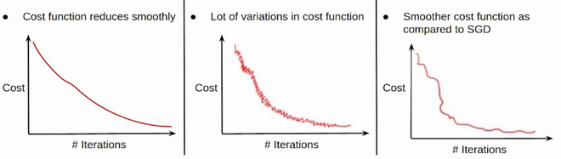
Convergence in BGD, SGD & MBGD
Mini-Batch Gradient Descent: Algorithm-
Let theta = model parameters and max_iters = number of epochs. for itr = 1, 2, 3, …, max_iters: for mini_batch (X_mini, y_mini):
- Forward Pass on the batch X_mini:
  - Make predictions on the mini-batch
  - Compute error in predictions (J(theta)) with the current values of the parameters
- Backward Pass:
  - Compute gradient(theta) = partial derivative of J(theta) w.r.t. theta
- Update parameters:
  - theta = theta – learning_rate*gradient(theta)
Below is the Python Implementation:
Step #1: First step is to import dependencies, generate data for linear regression, and visualize the generated data. We have generated 8000 data examples, each having 2 attributes/features. These data examples are further divided into training sets (X_train, y_train) and testing set (X_test, y_test) having 7200 and 800 examples respectively.

# importing dependencies
import numpy as np
import matplotlib.pyplot as plt

# creating data
mean = np.array([5.0, 6.0])
cov = np.array([[1.0, 0.95], [0.95, 1.2]])
data = np.random.multivariate_normal(mean, cov, 8000)

# visualising data
plt.scatter(data[:500, 0], data[:500, 1], marker='.')
plt.show()

# train-test-split
data = np.hstack((np.ones((data.shape[0], 1)), data))

split_factor = 0.90
split = int(split_factor * data.shape[0])

X_train = data[:split, :-1]
y_train = data[:split, -1].reshape((-1, 1))
X_test = data[split:, :-1]
y_test = data[split:, -1].reshape((-1, 1))

print(& quot
Number of examples in training set= % d & quot
% (X_train.shape[0]))
print(& quot
Number of examples in testing set= % d & quot
% (X_test.shape[0]))

Output:
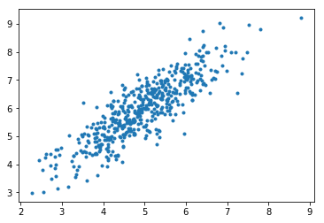
Number of examples in training set = 7200 Number of examples in testing set = 800
Step #2: Next, we write the code for implementing linear regression using mini-batch gradient descent. gradientDescent() is the main driver function and other functions are helper functions used for making predictions – hypothesis(), computing gradients – gradient(), computing error – cost() and creating mini-batches – create_mini_batches(). The driver function initializes the parameters, computes the best set of parameters for the model, and returns these parameters along with a list containing a history of errors as the parameters get updated.
Example

# linear regression using "mini-batch" gradient descent
# function to compute hypothesis / predictions

def hypothesis(X, theta):
return np.dot(X, theta)

# function to compute gradient of error function w.r.t. theta

def gradient(X, y, theta):
h = hypothesis(X, theta)
grad = np.dot(X.transpose(), (h - y))
return grad

# function to compute the error for current values of theta

def cost(X, y, theta):
h = hypothesis(X, theta)
J = np.dot((h - y).transpose(), (h - y))
J /= 2
return J[0]

# function to create a list containing mini-batches

def create_mini_batches(X, y, batch_size):
mini_batches = []
data = np.hstack((X, y))
np.random.shuffle(data)
n_minibatches = data.shape[0] // batch_size
i = 0

for i in range(n_minibatches + 1):
mini_batch = data[i * batch_size:(i + 1)*batch_size, :]
X_mini = mini_batch[:, :-1]
Y_mini = mini_batch[:, -1].reshape((-1, 1))
mini_batches.append((X_mini, Y_mini))
if data.shape[0] % batch_size != 0:
mini_batch = data[i * batch_size:data.shape[0]]
X_mini = mini_batch[:, :-1]
Y_mini = mini_batch[:, -1].reshape((-1, 1))
mini_batches.append((X_mini, Y_mini))
return mini_batches

# function to perform mini-batch gradient descent

def gradientDescent(X, y, learning_rate=0.001, batch_size=32):
theta = np.zeros((X.shape[1], 1))
error_list = []
max_iters = 3
for itr in range(max_iters):
mini_batches = create_mini_batches(X, y, batch_size)
for mini_batch in mini_batches:
X_mini, y_mini = mini_batch
theta = theta - learning_rate * gradient(X_mini, y_mini, theta)
error_list.append(cost(X_mini, y_mini, theta))

return theta, error_list

Calling the gradientDescent() function to compute the model parameters (theta) and visualize the change in the error function.

theta, error_list = gradientDescent(X_train, y_train)
print("Bias = ", theta[0])
print("Coefficients = ", theta[1:])

# visualising gradient descent
plt.plot(error_list)
plt.xlabel("Number of iterations")
plt.ylabel("Cost")
plt.show()

Output: Bias = [0.81830471] Coefficients = [[1.04586595]]
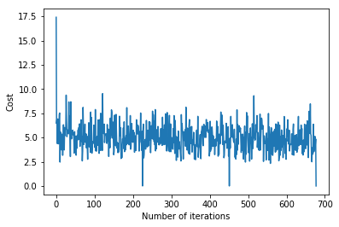
Step #3: Finally, we make predictions on the testing set and compute the mean absolute error in predictions.

# predicting output for X_test
y_pred = hypothesis(X_test, theta)
plt.scatter(X_test[:, 1], y_test[:, ], marker='.')
plt.plot(X_test[:, 1], y_pred, color='orange')
plt.show()

# calculating error in predictions
error = np.sum(np.abs(y_test - y_pred) / y_test.shape[0])
print(& quot
Mean absolute error = & quot
, error)

Output:
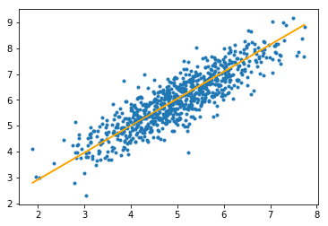
Mean absolute error = 0.4366644295854125
The orange line represents the final hypothesis function: theta[0] + theta[1]*X_test[:, 1] + theta[2]*X_test[:, 2] = 0

Optimization techniques for Gradient Descent
Gradient Descent is an iterative optimization algorithm, used to find the minimum value for a function. The general idea is to initialize the parameters to random values, and then take small steps in the direction of the “slope” at each iteration. Gradient descent is highly used in supervised learning to minimize the error function and find the optimal values for the parameters. Various extensions have been designed for the gradient descent algorithms. Some of them are discussed below:

Momentum method: This method is used to accelerate the gradient descent algorithm by taking into consideration the exponentially weighted average of the gradients. Using averages makes the algorithm converge towards the minima in a faster way, as the gradients towards the uncommon directions are canceled out. The pseudocode for the momentum method is given below.
V = 0
for each iteration i:
compute dW
V = β V + (1 - β) dW
W = W - α V
V and dW are analogous to velocity and acceleration respectively. α is the learning rate, and β is analogous to momentum normally kept at 0.9. Physics interpretation is that the velocity of a ball rolling downhill builds up momentum according to the direction of slope(gradient) of the hill and therefore helps in better arrival of the ball at a minimum value (in our case – at a minimum loss).
RMSprop: RMSprop was proposed by the University of Toronto’s Geoffrey Hinton. The intuition is to apply an exponentially weighted average method to the second moment of the gradients (dW2). The pseudocode for this is as follows:
S = 0
for each iteration i
compute dW
S = β S + (1 - β) dW2
W = W - α dW⁄√S + ε
Adam Optimization: Adam optimization algorithm incorporates the momentum method and RMSprop, along with bias correction. The pseudocode for this approach is as follows:
V = 0
S = 0
for each iteration i
compute dW
V = β1 S + (1 - β1) dW
S = β2 S + (1 - β2) dW2
V = V⁄{1 - β1i}
S = S⁄{1 - β2i}
W = W - α V⁄√S + ε
Kingma and Ba, the proposers of Adam, recommended the following values for the hyperparameters.
α = 0.001
β1 = 0.9
β2 = 0.999
ε = 10-8

ML | Momentum-based Gradient Optimizer introduction
algorithm are initialized to random values. As the algorithm iterates, the parameters are updated such that we reach closer and closer to the optimal value of the function.
However, Adaptive Optimization Algorithms are gaining popularity due to their ability to converge swiftly. All these algorithms, in contrast to the conventional Gradient Descent, use statistics from the previous iterations to robustify the process of convergence.

Momentum-based Optimization:
An Adaptive Optimization Algorithm uses exponentially weighted averages of gradients over previous iterations to stabilize the convergence, resulting in quicker optimization. For example, in most real-world applications of Deep Neural Networks, the training is carried out on noisy data. It is, therefore, necessary to reduce the effect of noise when the data are fed in batches during Optimization. This problem can be tackled using Exponentially Weighted Averages (or Exponentially Weighted Moving Averages).

Implementing Exponentially Weighted Averages:
In order to approximate the trends in a noisy dataset of size N:
, we maintain a set of parameters . As we iterate through all the values in the dataset, we calculate the parameters as below:
On iteration t:
Get next
This algorithm averages the value of over its values from previous iterations. This averaging ensures that only the trend is retained and the noise is averaged out. This method is used as a strategy in momentum-based gradient descent to make it robust against noise in data samples, resulting in faster training.
As an example, if you were to optimize a function on the parameter , the following pseudo-code illustrates the algorithm:
On iteration t:
On the current batch, compute
The HyperParameters for this Optimization Algorithm are , called the Learning Rate and, , similar to acceleration in mechanics.
Following is an implementation of Momentum-based Gradient Descent on a function :

import math

# HyperParameters of the optimization algorithm
alpha = 0.01
beta = 0.9

# Objective function
def obj_func(x):
return x * x - 4 * x + 4

# Gradient of the objective function
def grad(x):
return 2 * x - 4

# Parameter of the objective function
x = 0

# Number of iterations
iterations = 0

v = 0

while (1):
iterations += 1
v = beta * v + (1 - beta) * grad(x)

x_prev = x

x = x - alpha * v

print("Value of objective function on iteration", iterations, "is", x)

if x_prev == x:
print("Done optimizing the objective function. ")
break

